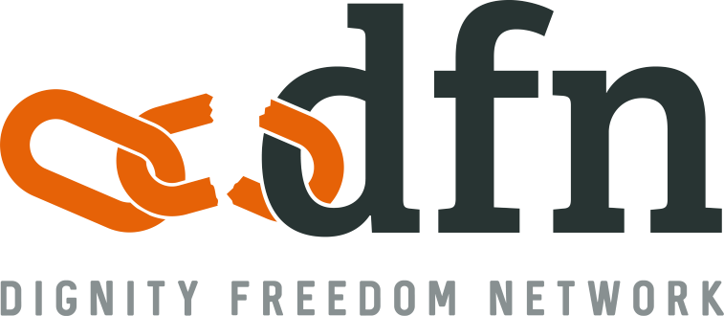

Youth Ambassador Program – Passion Project Form
In order to apply for either the DFN Youth Ambassador Team Leader or Team Member positions you must:
- Submit this Passion Project Form
- Submit the Personal Information Form
- Submit both forms online or by email to youthambassador@dfn.org.au by Friday July 19th, 2019

Full Name:

Date of Birth: Current Age:

Email: Phone:

Address:

School (if applicable):

To complete this form you will need to outline an idea for a Passion Project that you could complete with the help of a team within a 6 month timeframe (July 2019 – December 2019). Your Passion Project should focus on one of the four key areas that DFN works with in India and raise both funds and awareness for the cause.

DFN carries out work in:
Health Care

- DFN employs Community Health Workers who provide rural, marginalised communities with health care and basic hygiene information that they are so often refused.
- Mobile Health Clinics operate around India, travelling to marginalised communities to share the love of God and provide medical checkups.
- Permanent Health Clinics are being constructed in strategic impoverished areas to ensure the healthy growth of future generations.
Economic Development

- Providing business grants to women so they can purchase a cart and some goods to sell. These grants also provide the women with basic business training to ensure business sustainability.
- Purchasing buffaloes for families so they can have enough milk for the family as well as sell the surplus.
Anti-Human Trafficking

- The Jogini Practice is where young girls are dedicated to the temple Goddess, becoming a sexual slave for the village. DFN work to educate these women, show them they have worth through rehabilitation, and help them leave this illegal and atrocious system. Jogini Village Leaders and Community Health workers are employed to carry out this work.
- A new shelter is being constructed to take in young girls who are identified as at-high-risk of being dedicated. Often, they already have Joginis in their family and when the opportunity is there for them to escape dedication their families are very grateful.
Education

- Child Sponsorships are raised so that marginalised children can go to school. Often, these children are refused education because of their caste.
- Education provides vital opportunities for vulnerable children to escape systemic poverty by gaining employable skills in areas such as maths, English, Hindi literacy and global awareness.

- What is the Key Area you would like to focus on and why?

- In no more than 30 words, give a summary of your proposed project

- What resources will you need to carry out this project?

- Provide a simple table of what you plan to achieve each month in order to complete your project. Note that your project planning and implementation should be carried out over a 6 month period (July 2019 – December 2019)

- What is your goal for completing this project? Be specific & realistic in your goals: you might think about specifically how many people you aim to speak to OR how many presentations you want to give – 5? 10? OR how much money you aim to raise - $200? $1000?

youthambassador@dfn.org.au
www.dfn.org.au/youth-ambassador
1 800 949 774

